# 2st TASK: Fetch dataset from Kaggle.com, clean it and create a sub data frame then save it as CSV and make it available on web in form of a html table using FLASK.

Solution:

Here are the steps, code and tool used for this task.

1. Jupiter notebook is used to fetch dataset from Kaggle with the help of **Kaggle API** , perform some cleaning manipulations and saved as a csv.

**Here is code:**

import pandas as pd

#install kaggle

!pip install kaggle

# TO import kaggle we need to downlaod the kaggle API authentication file Kaggle.json, from our kaggle account.

import kaggle

# this is just to confirm that our kaggle is configure correctly and we can import our kaggle API

!kaggle –version

#To initialize API

from kaggle.api.kaggle_api_extended import KaggleApi

api = KaggleApi()

api.authenticate()

# downloading data set from kaggle.com Zeeshan Usmani's on startups

api.dataset_download_file('zusmani/pakistans-largest-ecommerce-dataset',

file_name = 'Pakistan Largest Ecommerce Dataset.csv',

path='./')

# The downloaded file is in zip file and needs to be unzipped to read it as csv, we can do it with python **IMPORT zipfile** but I was having some issue doing that, hence I extracted it manually and read it as csv.

df = pd.read_csv('Pakistan Largest Ecommerce Dataset.csv', low_memory=False)

# some cleaning, re-arranging and creating sub data frame

df_sub = df[["item_id", "status","price","grand_total","category_name_1"]]

df_sub = df_sub.dropna()

df_sub = df_sub.sort_values(by = ['grand_total'], inplace = False, ascending = False)

df_sub=df_sub.head(10)

df_sub.rename(columns={'category_name_1':'Market'}, inplace = True)

# Saving data in a CSV file.

df_sub.to_csv("Top10_startups.csv", index = False)

1. Visual code is used here: With flask the fetched data is read and converted into HTML from CSV with render function and HTML table template , then made available at local host(<http://127.0.0.1:5000/>)

**Code for flask app:**

# importing flask

from flask import Flask, render_template

# importing pandas module

import pandas as pd

app = Flask(__name__)

# reading the data in the csv file

df = pd.read_csv(‘Top10_startups'.csv')

df.to_csv(' Top10_startups.csv', index=None)

# route to html

@app.route('/')

@app.route('/table')

def table():

# converting csv to html

data = pd.read_csv(' Top10_startups'.csv')

return render_template('table.html', tables=[data.to_html()], titles=[''])

if __name__ == "__main__":

app.run(host="localhost", port=int("5000"))

**HTML tamplate used:**

<!DOCTYPE html>

<html lang="en">

<head>

<title> Table </title>

</head>

<body>

<div align="center">

<table>

<h1>

<!--Displaying the converted table-->

{% for table in tables %}

<h2>{{titles[loop.index]}}</h2>

{{ table|safe }}

{% endfor %}

</h1>

</table>

</div>

</body>

</html>

**Web snap:**

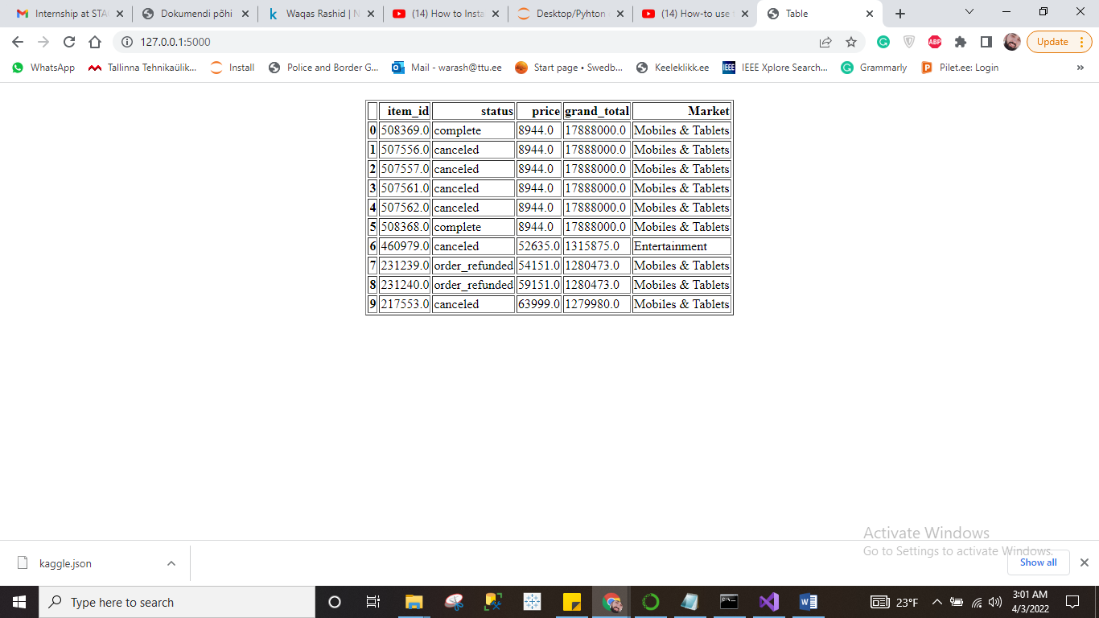

**CMD window:**

